iLabs Sample Registration

- Login
Prior to starting the sample registration you need to login to your iLabs account. If not set-up already you will need to create an account, activation may take up to 24 hours and the facility cannot speed this up since we have no influence on the registration process. Likewise we cannot see or reset passwords.
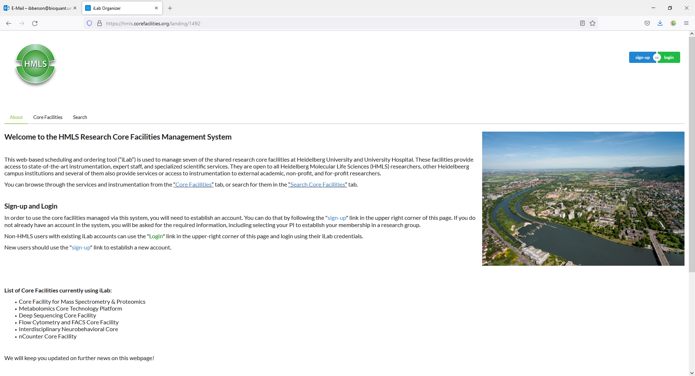

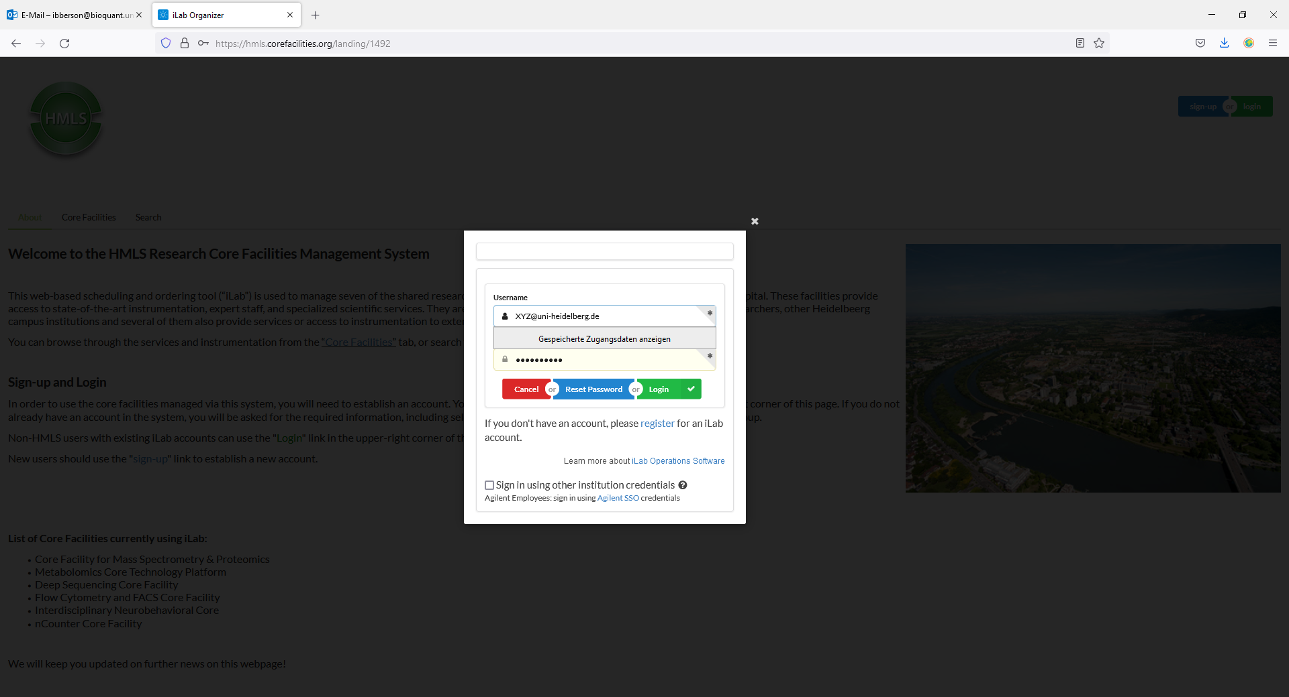
- Select „Request Services“
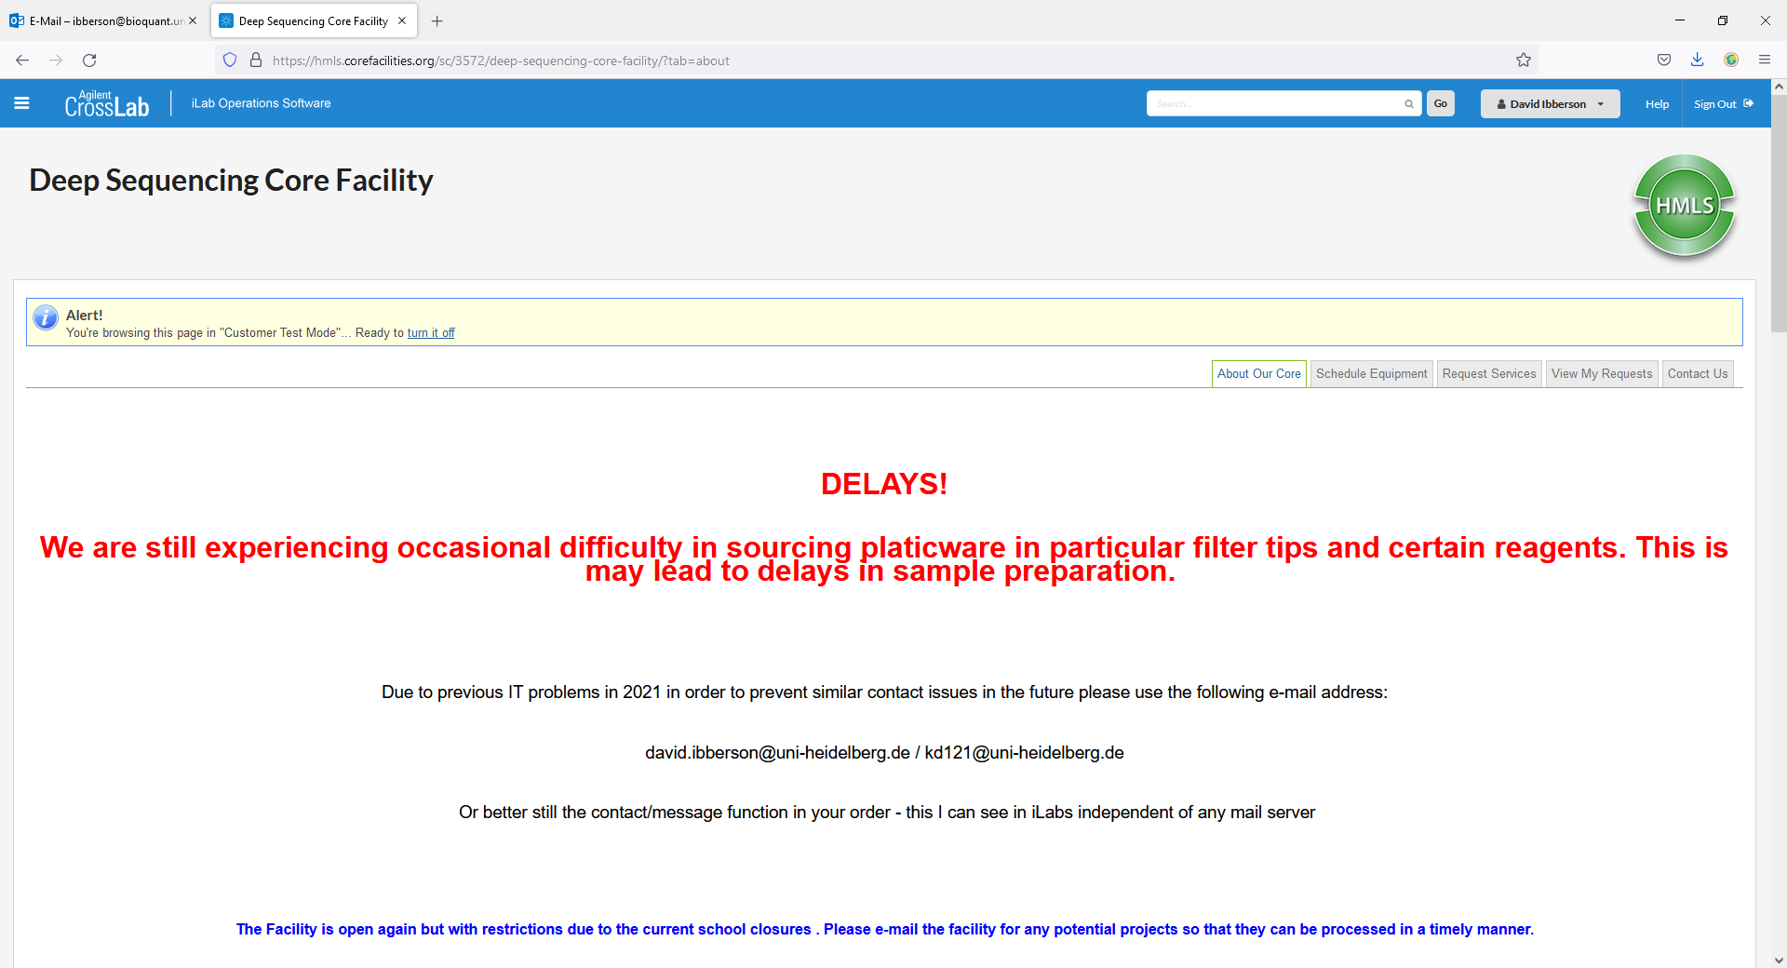

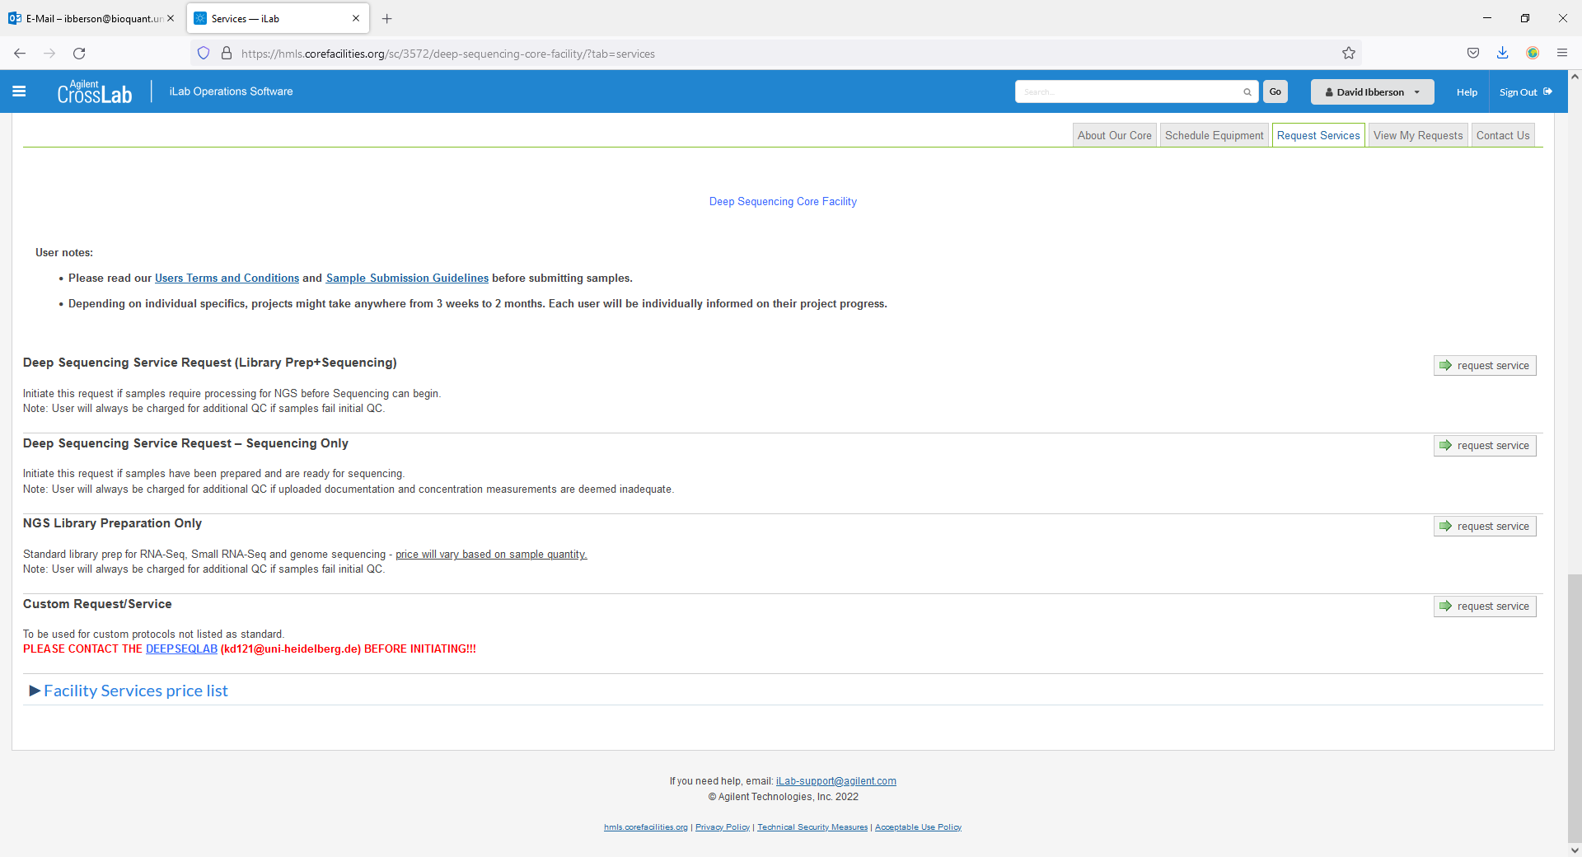
There are four types of services to choose from:
1 – Library Prep and Sequencing – Select this if you need your samples to be prepared for sequencing and sequenced with us.
2 – Sequencing only – Select this if you have ready-to-load libraries
3 – Library Preparation only – Select this if you need you samples to be prepared for sequencing on the Illumina platform but wish to sequence elsewhere. You will still be asked which instrument you wish to sequence on, as this can be important for the library preparation and subsequent pooling
4 - Custom Request - Please contact us prior to selecting this.

Registering Your Sample(s)
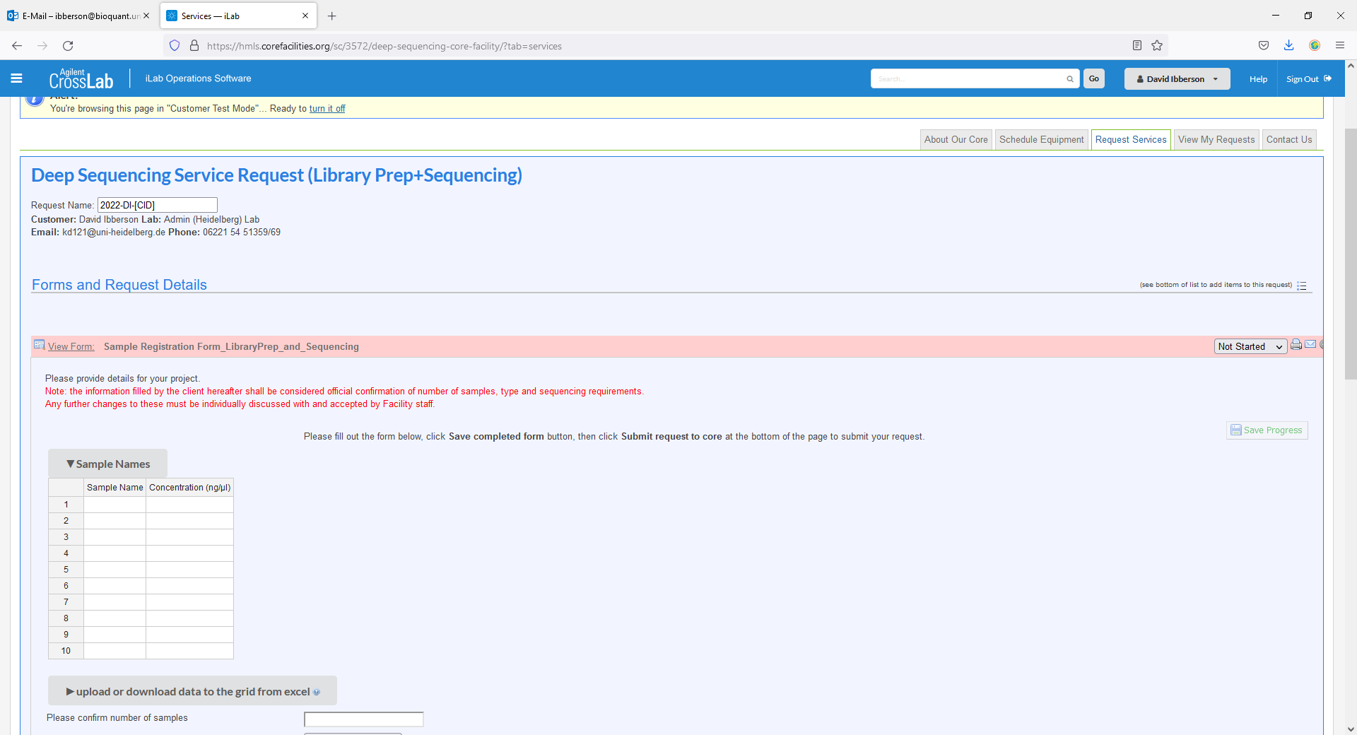

Regardless of request type please enter your sample name(s) and their concentrations in the table. In the case of User Provided Libraries (Sequencing only), barcode sequences are also required.

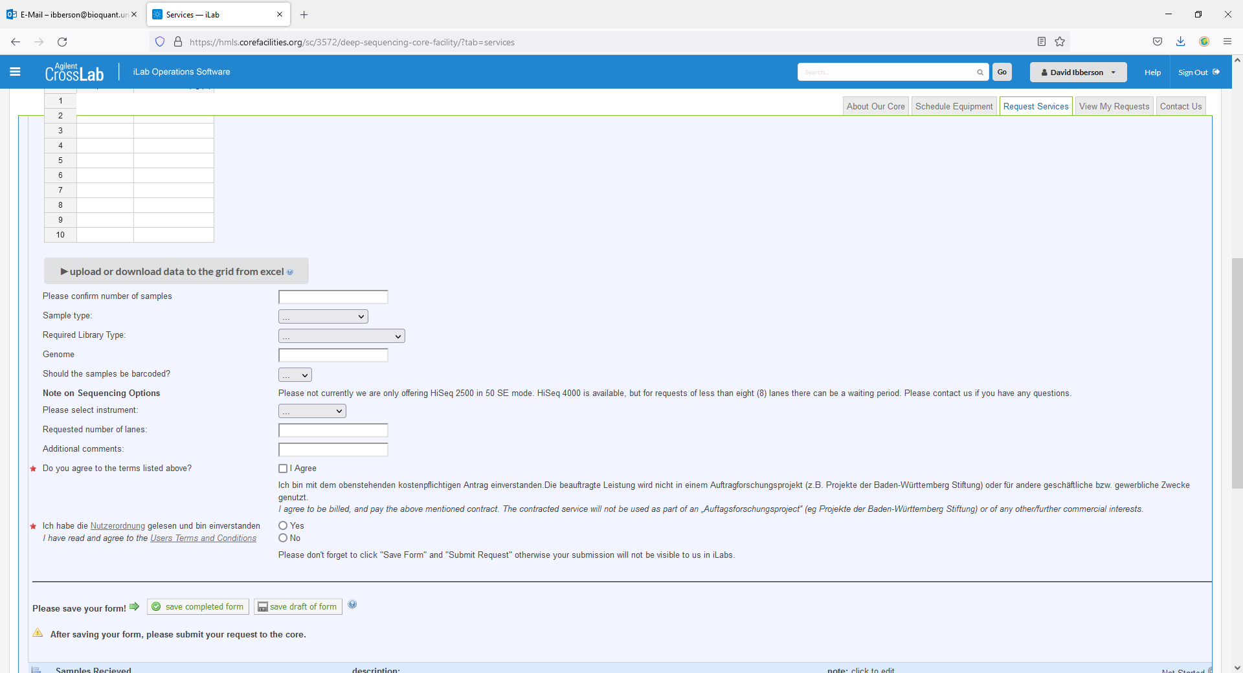
The next step is to fill in the information as to what type of Library Preparation is required and what the origin of the sample is. These are drop down menus, so please look carefully. In the case of custom preparations an extra box will appear.
Afterwards please select the sequencing type required. This changes regularly, so it may be the case that the sequencing type requested is no longer available, in this case an alternative will be offered.

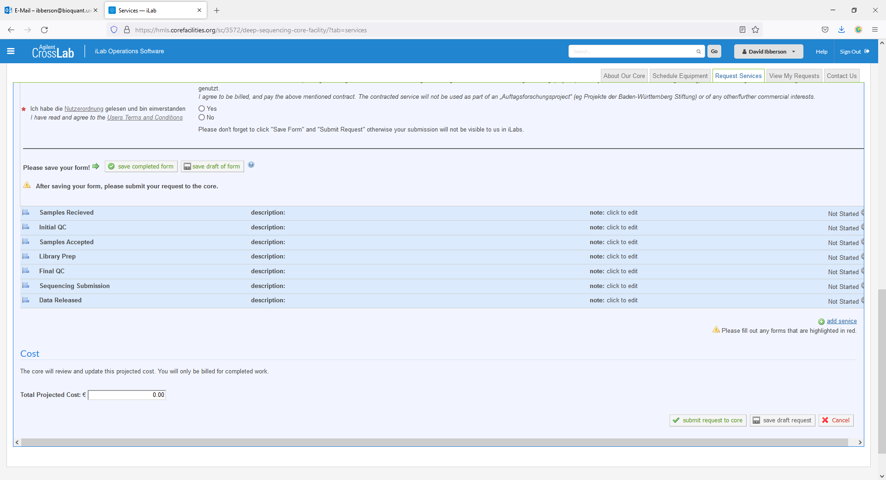
Finally, please do not forget to click „save“ and „submit request“ otherwise we will not see the request.

After request submission, you will be provided with a cost estimate (which requires confirmation from yourself or PI). In addition, the order will be locked, so no changes can be made without confirmation by the facility.
Checking the progress of your sample submission:
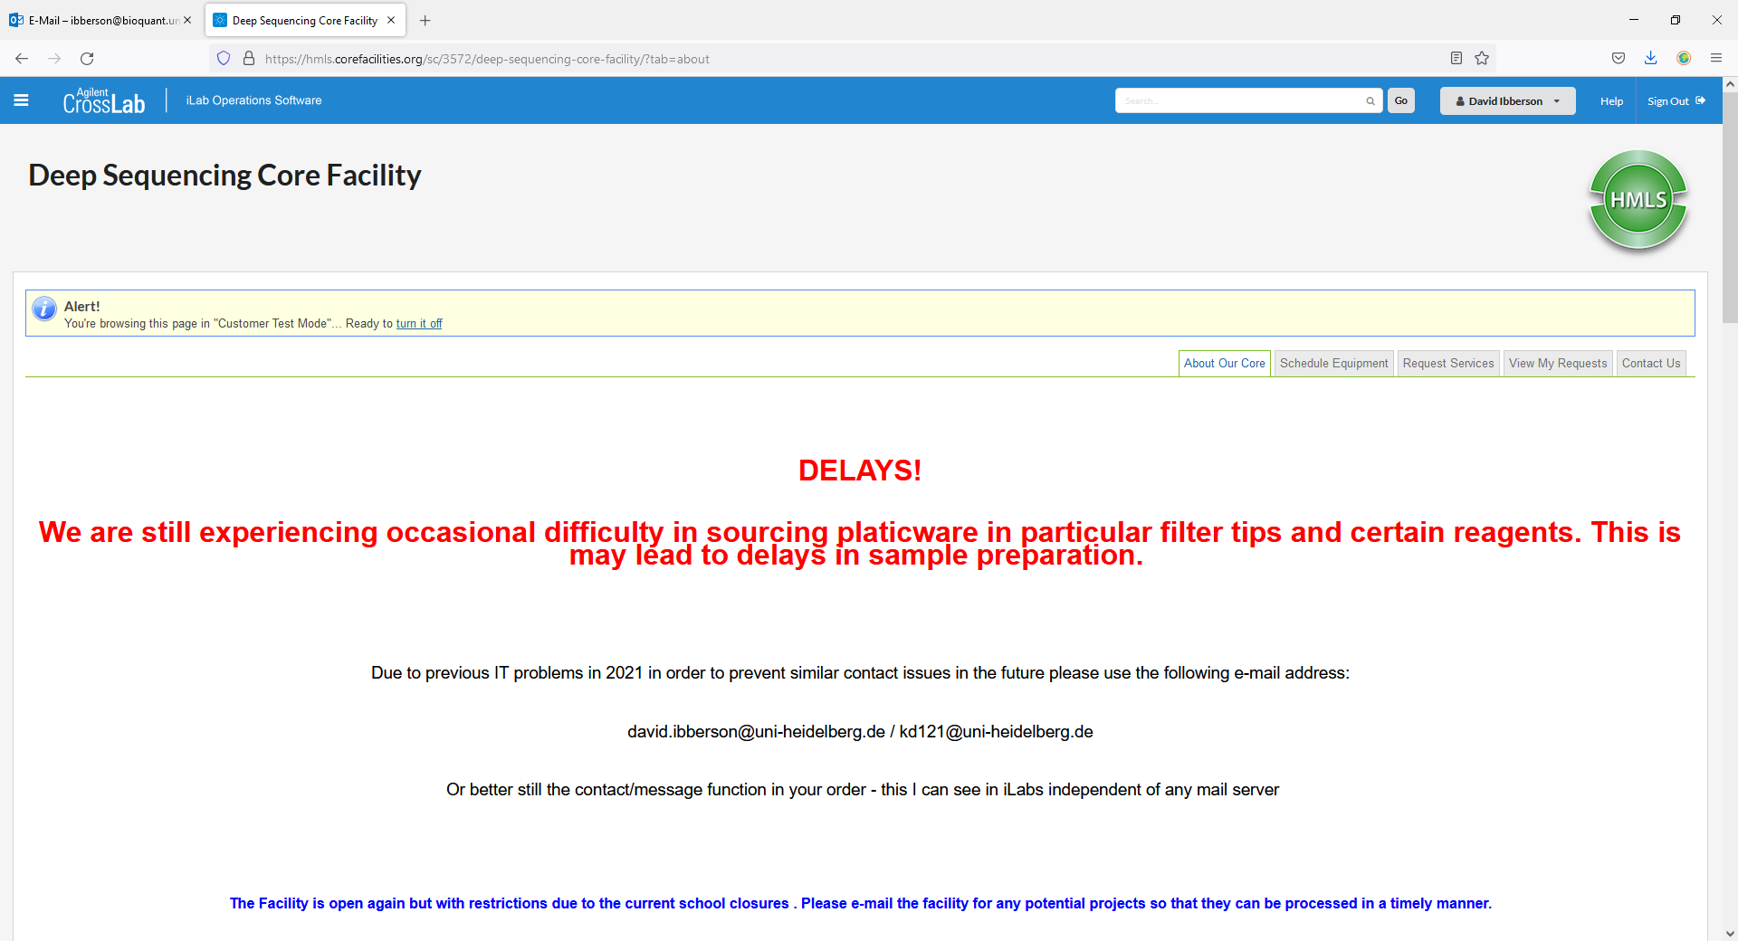

- You can keep track of the progress of your order by clicking on the tab „View My Requests”
- Upon clicking this, a list of your requests will become available
- By clicking the blue arrow on the left of your request, a drop down screen will open and here you can see the status of your request.

